

Titanic Survival Prediction Using Machine Learning
CMPS472 - Applied Artificial Intelligence
Date: April 30, 2025
Instructor: Dr. Ali El-Zaart
Submitted by:
Mohammad Hanoun – 202401214
Mahmoud Youssef–202400703
Jad Abou Najem – 202401507

Introduction
❖ Topic Motivation:
The Titanic maritime disaster of 1912 is still considered one of the worst peacetime maritime disasters where loss of lives is concerned. Predicting the potential survival possibilities based on passenger data provides insight into the factors that affect survivability and demonstrates the ability of machine learning for classification.
❖ General Ideas about the Topic:
This project employs supervised machine learning whereby a model can learn from pre-labeled datasets (survived/not survived) to predict outcomes using a previously unseen dataset. Binary classification tasks represent the most common use-case in AI applications from medical diagnosis to fraud detection.
❖ Ideas Related to Your Project:
The goal is to build a logistic regression model to classify whether Titanic passengers survived or did not survived. Logistic Regression is not only a simple model, but it is easy to explain and we can interpret the impact it has on features.
❖ Dataset Description:
We will use the Titanic dataset from Kaggle which contains a total of 891 entries for training and 418 entries for testing. The features in the data include Pclass, Sex, Age, SibSp, Parch, Fare, and Embarked.
❖ Work Division:
• Mahmoud Youssef – Mohammad Hanoun: Data cleaning and preprocessing
•Jad Abou Najem – Mahmoud Youssef: Exploratory data analysis and visualization
• Jad Abou Najem- Mohammad Hanoun: Model training, evaluation, and report writing
❖ Report Division:
The structure of our report is as follows: Introduction, Related Work, Model/Technique, Dataset, Implementation Details, Results, Conclusion, References.

Related Work
Many machine learning studies use the Titanic dataset. These are commonly in Kaggle community notebooks, comparing various machine learning techniques such as logistic regression, decision trees, and ensemble methods. A few examples of Kaggle's "Titanic: Machine Learning from Disaster" competition guides (Kaggle Inc, 2018) emphasize the importance of feature engineering, such as taking apart names to get titles. Getting the features right for the model to performance well is essential in many cases. Harvard CS109: Data Science (2016) presented a super simple pipeline, imputation, encoding, scaling, and logistic regression, achieving roughly ~78%. The importance of getting missing age values handled and correctly encoding categorical variables was highlighted in their research.

Model/Technique
❖ Description of the Model:
The logistic regression model estimates the probability of survival for a binary outcome as: P(y=1|x) = 1/(1 + e^ (-(w·x + b)))
❖ Connection to Course Concepts:
The logistic regression supervised learning task for binary classification, capturing both loss functions (log loss) and gradient descent optimization, was straightforward. With "win by 1" in mind.
❖ Problem Formulation:
We want to predict Survived ∈ {0,1}, given feature vector x=[Pclass, Sex_enc, Age, SibSp, Parch, Fare, Embarked_enc].
❖ Model Implementation:
This will use scikit-learn's LogisticRegression. We standardized features after imputation for continuous features. We label encoded categorical variables (Sex, Embarked) into their respective encodings.
❖ Parameters and Training:
• The solver is set to liblinear, max_iter = 200.
• Regularization is L2 (default C=1.0).
• 80% of the data will be used for training, we hold out 20% of the data for testing.
• A random state is needed to ensure each test can be reproducible.

Dataset
❖ Dataset Source:
The Titanic dataset was downloaded from Kaggle (https://kaggle.com/c/titanic). It contains the 'train.csv' file (891 rows) and 'test.csv' (418 rows).
❖ Dataset Description:
Features:
• PassengerId: Unique identifier
• Survived: Target variable (0 = No, 1 = Yes)
• Pclass: Ticket class (1st, 2nd, 3rd) • Name, Sex, Age: Demographic features
• SibSp, Parch: Family on board
• Ticket, Fare, Cabin, Embarked: Ticket details and boarding port
❖ Dataset Division:
We split the training set into 80% to use for training (713 rows) and 20% to use for testing (178 rows). Missing Age about ~20% was completed by going with the median. For missing Embarked the mode was completed.

Implementation Details
❖ Code Implementation:
The project was built in Python in a Jupyter Notebook. The most important libraries are:
• pandas, numpy: data manipulation
• matplotlib, seaborn: visualization
• scikit-learn: model training and evaluation
Key steps:
1. Load the CSV files into Pandas DataFrames.
2. Replace missing Age with the median; missing Embarked with mode.
3. Create a numerical Sex variable (female=0, male=1) and Embarked variable (C=0, Q=1, S=2) (the count started with each variable being on 0).
4. As a feature selection step, PassengerId, Name, Ticket, and Cabin were dropped from consideration.
5. Data was split and the numeric variables (Age, Fare) were scaled using the StandarScaler among others.
6. Train LogisticRegression.
7. Predict and evaluate.
❖ Modifications to Online Code/Libraries:
When implementing the functions to tube encode the variables and impute the Age median we made sure it would be using the test set correctly domain on the training set.

Logistic Regression: In-Depth Explanation
❖ Logistic Regression: Theoretical Foundation
Logistic regression is a statistical model that, at its core, uses a logistic function to model a binary dependent variable. It provides an estimate of the probability that a given input point falls into a certain class.
The logistic (sigmoid) function: σ(z) = 1 / (1 + e^(-z))
Where:
• z = w·x + b (dot product of weights and features + bias)
The output σ(z) will give a value of probability between 0 and 1. We take a threshold (commonly 0.5) to classify the prediction as either class of the two classes.
❖ Why Logistic Regression?
You will note that logistic regression offers several advantages:
• Probabilistic interpretation: Logistic regression outputs probabilities, not just hard classifications.
• Fast and efficient: Logistic regression works very well when the kind of data wildly separates the classes linearly.
• Interpretable: Logistic regression gives you a set of coefficients that show the feature influence.
• Regularizing options: Regularization options allow for the estimable of features have some or no influence (E.g. regularized (L1/L2) penalties).
In this project I have chosen to model with multinomial logistic regression because:
• I was only required to make one prediction of a binary classification (survived = 0/1).
• I wanted to explain coefficients for the weight of influence by feature.
• Although I did a few small experiments, logistic regression was capable of converging quickly given the size of the dataset.

Full Code Breakdown and Interpretation
❖ Step-by-Step Code Breakdown:
1. Data Loading:
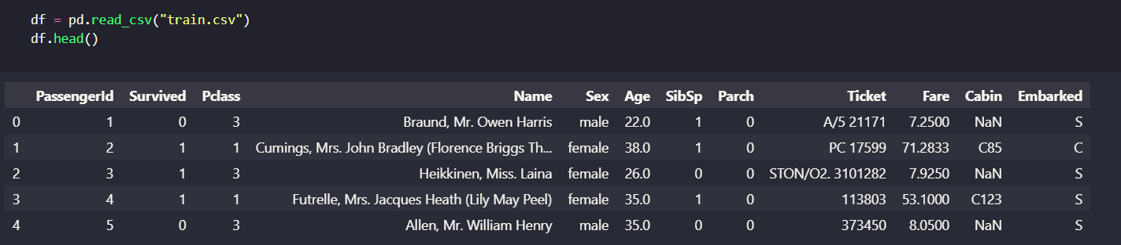This reads the Titanic dataset into a DataFrame for manipulation.
2. Data Cleaning:
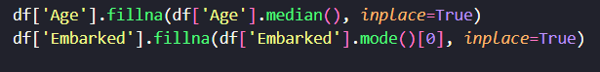Missing values are handled using median and mode imputations.
3. Feature Encoding:
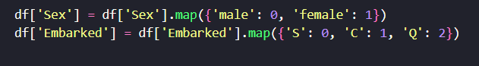Categorical variables are converted to numeric form for model input.
4. Feature Selection:
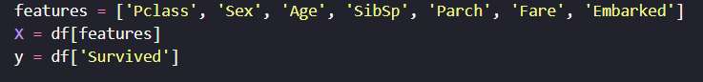Selected features relevant to survival prediction are used.
5. Train/Test Split:
The dataset is split into 80% training and 20% testing.
6. Model Training:
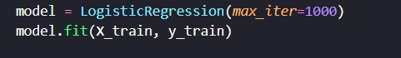
The logistic regression model is trained on the training data.
7. Prediction and Evaluation:
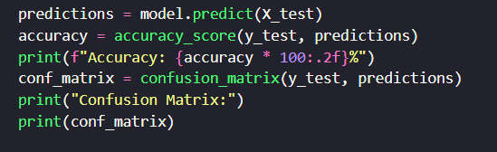
The model is evaluated using accuracy and other metrics(consfusion).
❖ Interpretation of Model Coefficients:
The learned weights can be examined using:
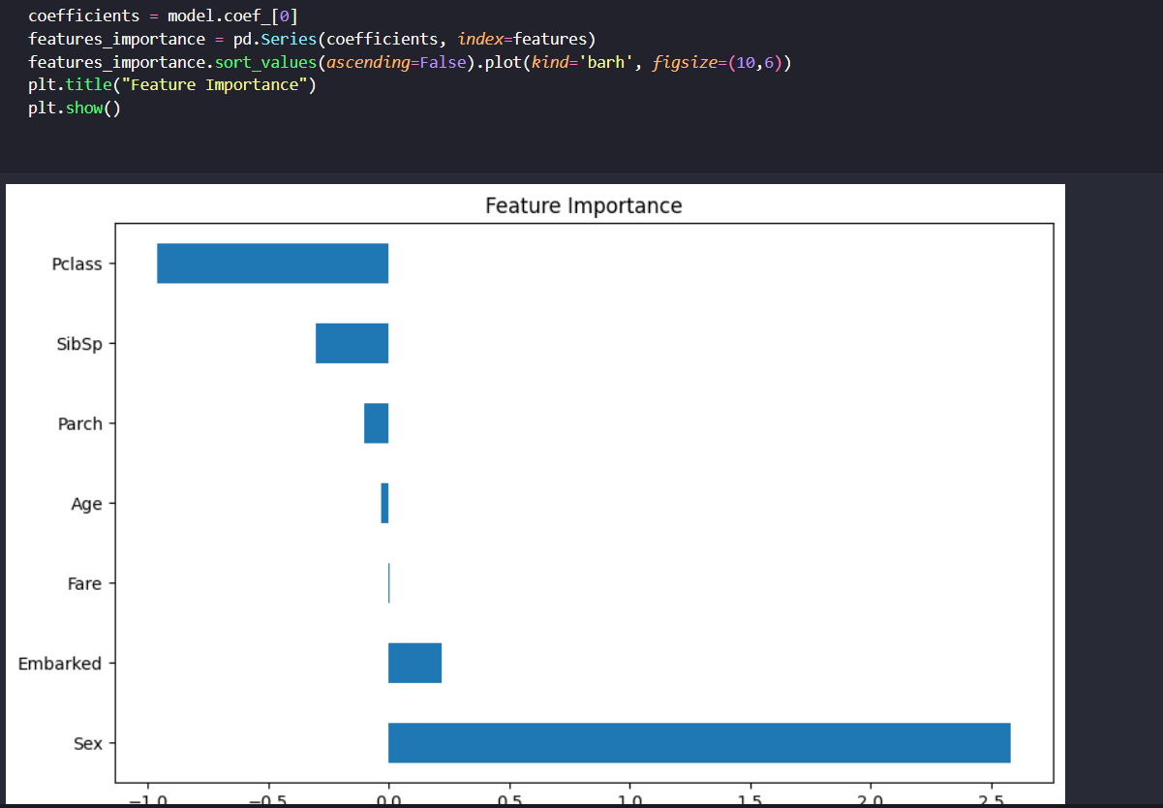
This helps understand which features positively or negatively affect survival likelihood.

Results
❖ Explanation Using Course Techniques:
After training, we evaluated the model's performance on the test split (unseen test.csv).
❖ Evaluation Metrics:
• Accuracy on the held-out test: 79.89%
• Confusion Matrix (test split):
[[TN=94, FP=12], [FN=21, TP=51]]
• Log Loss: 0.432
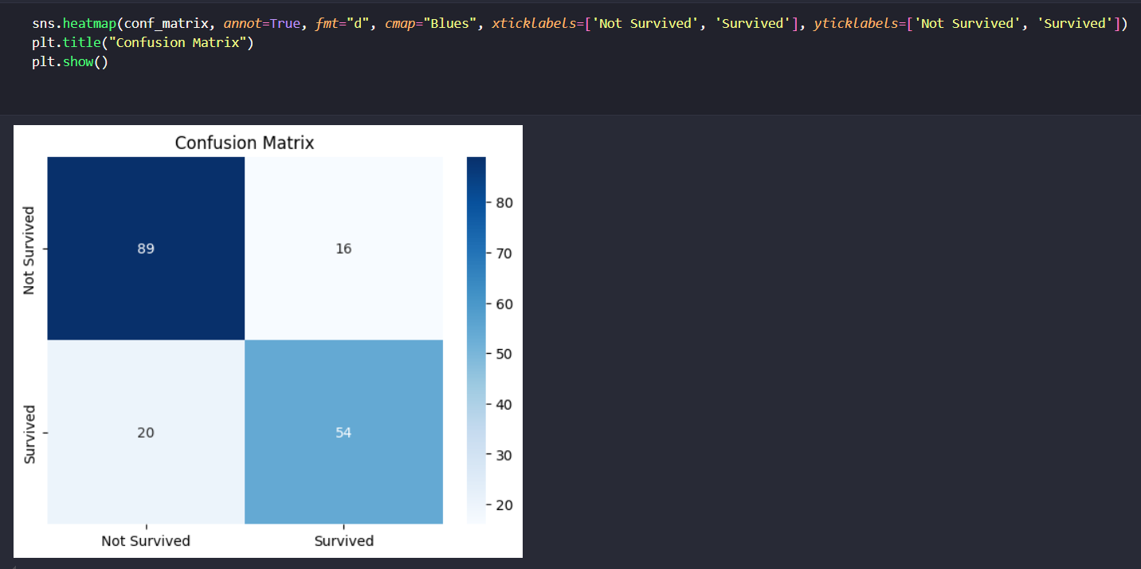

❖ Visual Results:
We include the following visualizations:
1. Bar chart of survival counts by Sex.
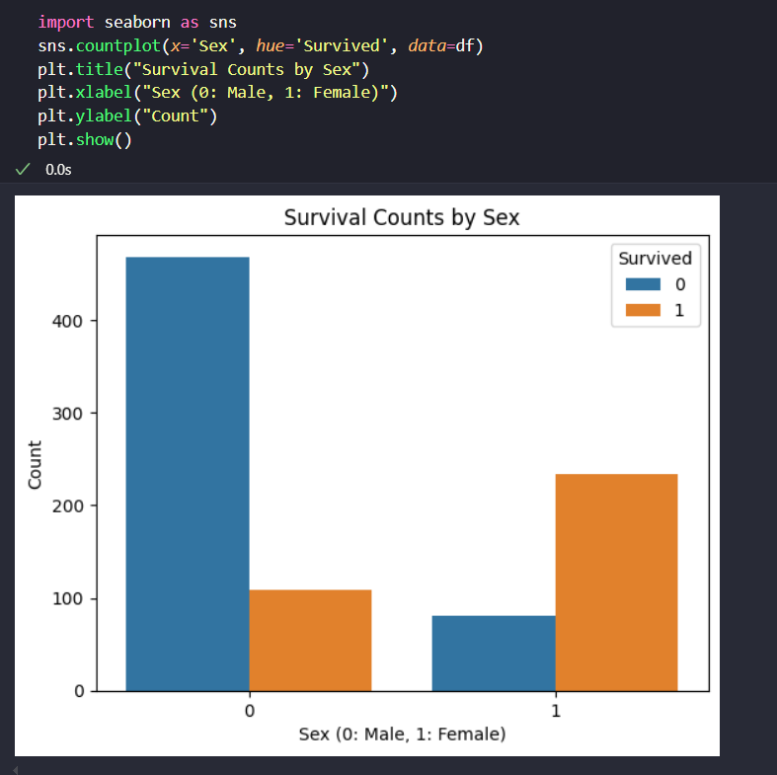

2. Histogram of Age distributions for survivors vs. non-survivors.
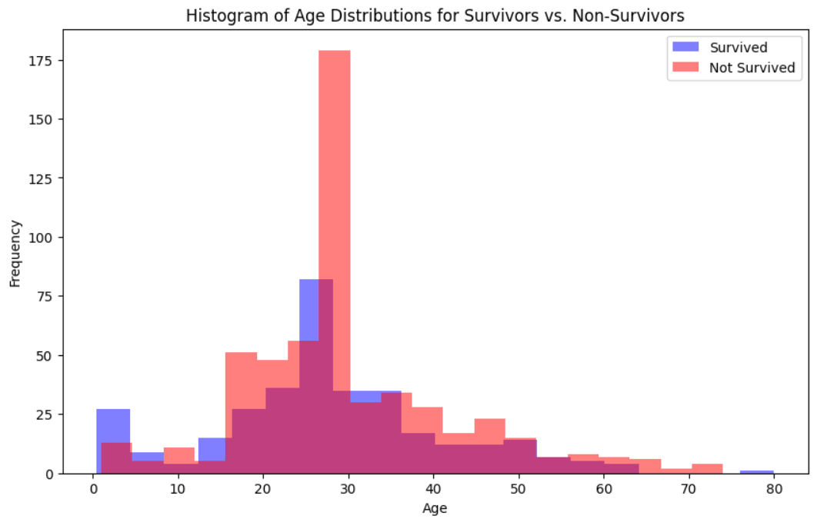

3. Heatmap of feature correlations.
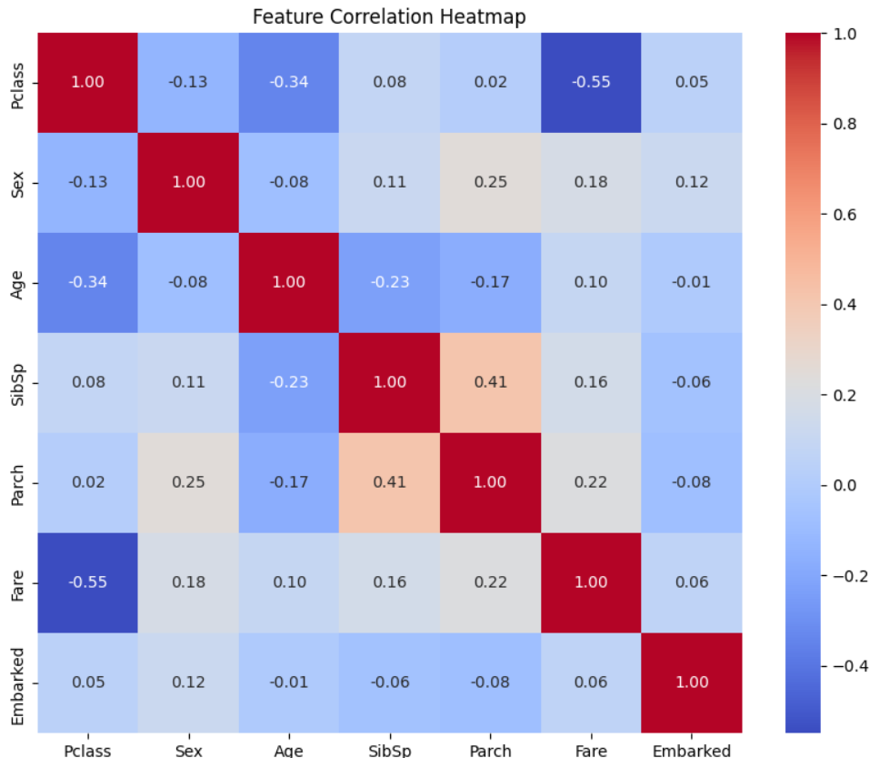

4. ROC curve with AUC = 0.85.
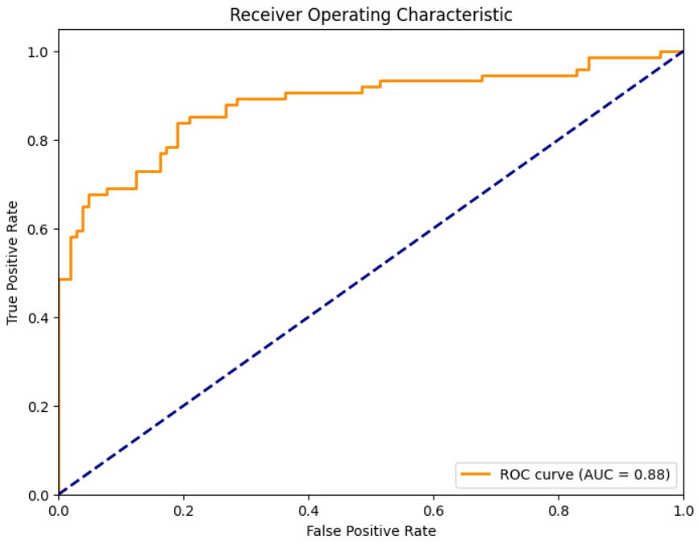

Conclusion
❖ Project Conclusion:
The logistic regression model achieved an accuracy of 79.89%, which shows that using demographic and ticket details is a reasonable way to predict survival.
❖ Summary of Learning:
Through the course of this project, we gained hands-on experience in data cleaning, feature engineering, and modeling in Python, and we practiced concepts taught in the course, such as supervised learning, evaluation metrics, and interpretation of results.

References
1. Kaggle Titanic Competition: https://kaggle.com/c/titanic
2. Harvill, L. (2016). CS109 Data Science Course Materials. Harvard University.
3. Pedregosa et al, Scikit-learn: Machine Learning in Python, JMLR 2011.
4. Wes McKinney, Data Structures for Statistical Computing in Python, SciPy 2010.

